**Practical: 1**

**Aim: C program to create a file and write data into file.**

**Program:**

#include <stdio.h>

int main()

{

FILE * fp;

char data[100];

fp = fopen("demo.txt", "w");

if(fp != NULL)

{

printf("File open...\n");

printf("enter yor data : \n");

gets(data);

fputs("\n",fp);

fputs(data,fp);

printf("\ndata written sucessfully....");

}

else

{

printf("file failed...");

}

fclose(fp);

return 0;

}

**Output:**

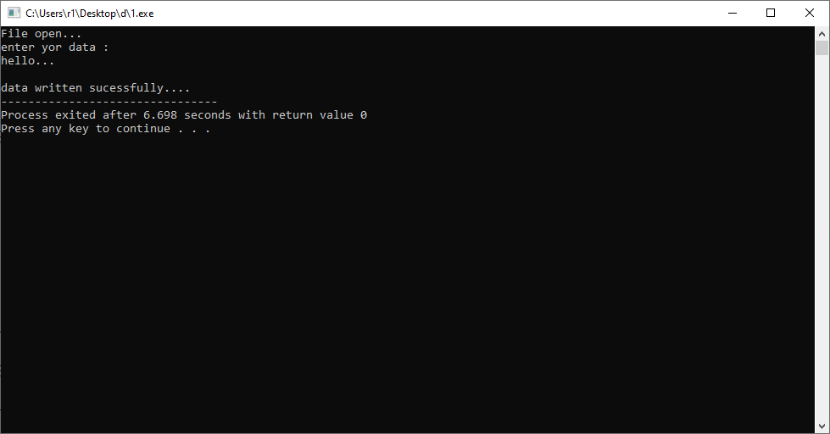

**Practical: 2**

**Aim: C program to read a file and display its contents.**

**Program:**

#include<stdio.h>

main()

{

FILE *f;

char data[1000];

f = fopen("demo.txt","r");

if(f==NULL)

{

printf("unable to open file.\n");

printf("please check whether file exists and your read privilege.\n");

}

else

{

printf("file opened successfully. Reading file conmtents character by charecter.\n\n");

}

while(fgets(data,3,f)!=NULL)

{

printf("%s",data);

}

fclose(f);

}

**Output:**

**Practical: 3**

**Aim:C program to write even, odd and prime numbers to separate file.**

**Program:**

#include <stdio.h>

#include <stdlib.h>

int isEven(const int NUM)

{

return !(NUM & 1);

}

int isPrime(const int NUM)

{

int i;

if (NUM < 0)

return 0;

for ( i=2; i<=NUM/2; i++ )

{

if (NUM % i == 0)

{

return 0;

}

}

return 1;

}

int main()

{

FILE *fPtrIn, *fPtrEven, *fPtrOdd, *fPtrPrime;

int num, success;

fPtrIn = fopen("demo_1.txt", "r");

fPtrEven = fopen("even.txt" , "w");

fPtrOdd = fopen("odd.txt" , "w");

fPtrPrime= fopen("prime.txt", "w");

if(fPtrIn == NULL || fPtrEven == NULL || fPtrOdd == NULL || fPtrPrime == NULL)

{

printf("Unable to open file.\n");

printf("Please check whether file exists and you have read/write privilege.\n");

exit(EXIT_FAILURE);

}

printf("File opened successfully. Reading integers from file. \n\n");

while (fscanf(fPtrIn, "%d", &num) != -1)

{

if (isPrime(num))

fprintf(fPtrPrime, "%d\n", num);

else if (isEven(num))

fprintf(fPtrEven, "%d\n", num);

else

fprintf(fPtrOdd, "%d\n", num);

}

fclose(fPtrIn);

fclose(fPtrEven);

fclose(fPtrOdd);

fclose(fPtrPrime);

printf("Data written to files successfully.");

return 0;

}

**Output:**

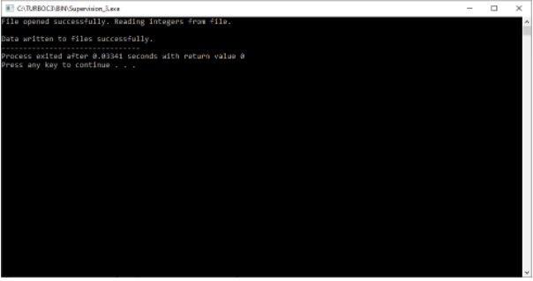

**Practical: 4**

**Aim: C program to append data into a file.**

**Program:**

#include <stdio.h>

#include <string.h>

int main()

{

FILE *fp;

char str[80];

fp = fopen("demo.txt", "a");

printf("Enter your message:");

gets(str);

fputs("\n",fp);

fprintf(fp, "%s",str);

printf("Your message is appended in demo.txt file.");

fclose(fp);

return 0;

}

**Output:**

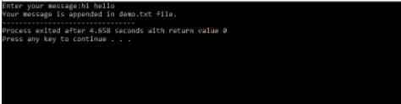

**Practical: 5**

**Aim: C program to copy contents from one file to another.**

**Program:**

#include<stdio.h>

main()

{

FILE *fp1,*fp2;

char data[1000];

fp1 = fopen("demo.txt","r");

fp2 = fopen("demo_1.txt","w");

while(fgets(data, 3, fp1) != NULL)

{

fputs(data, fp2);

}

printf("File comied successfull...\n");

fclose(fp1);

fclose(fp2);

}

**Output:**

